**Homework 2**

**Main Code**

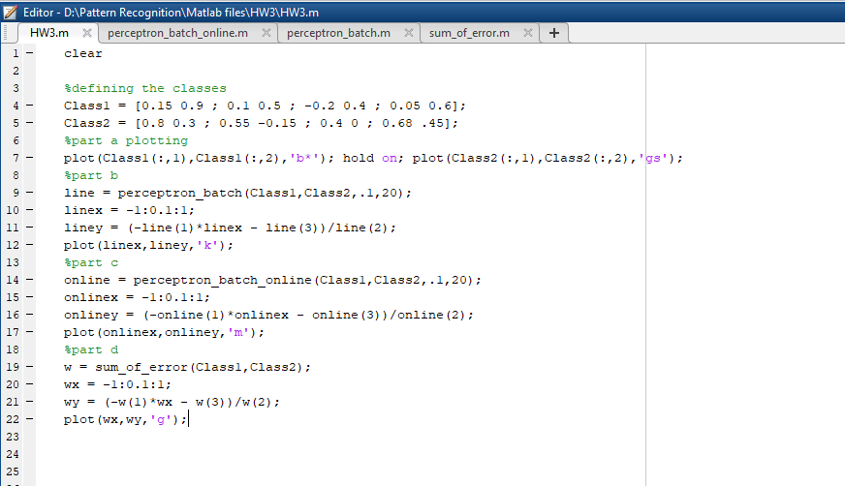

Figure 1 Main code

Part a) plotting Class1 and Class2

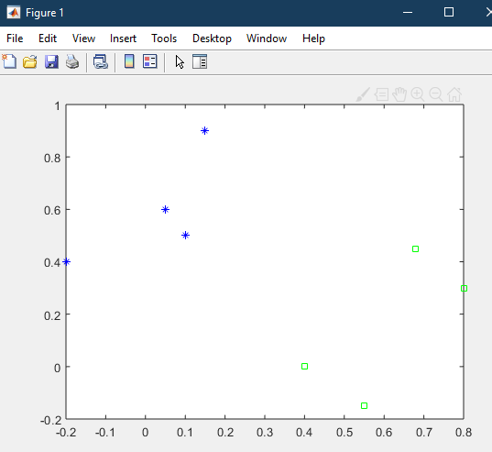

Figure 2 part a

Part b) using the batch version given ( black line )

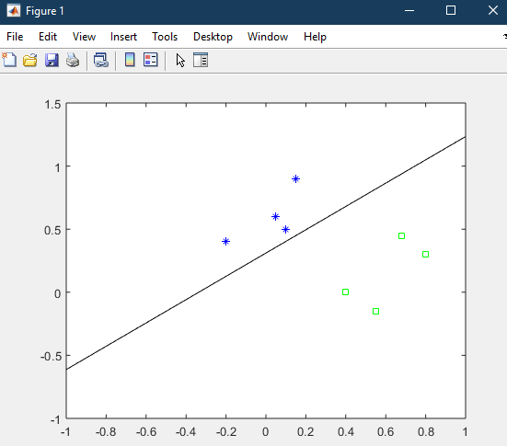

Figure 3 part b

Part c) using the online perceptron algorithm ( magenta line )

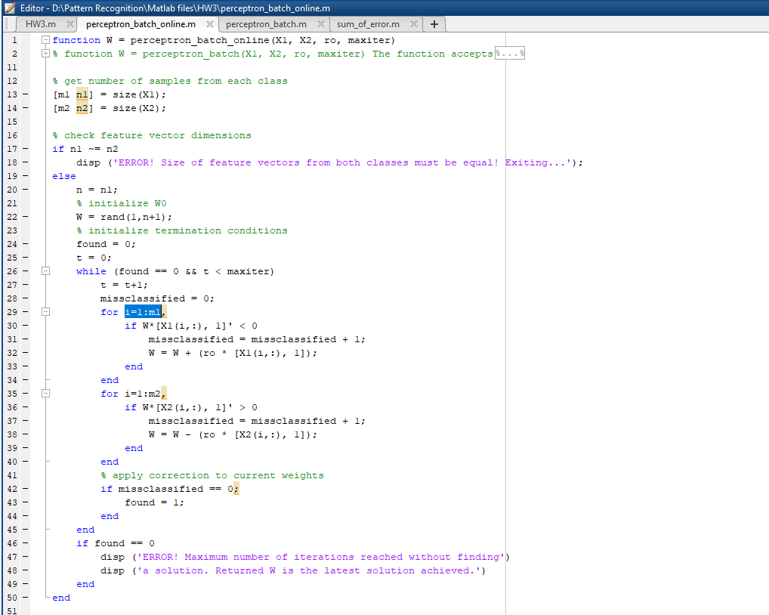

Figure 4 part c full code

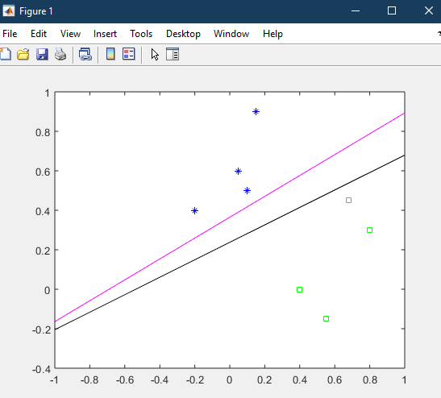

Figure 5 part c plot

Part d) using the sum of errors algorithm ( green line )

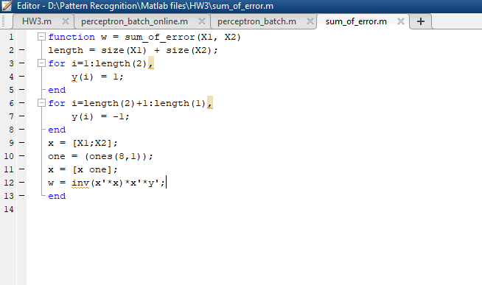

Figure 6 part d full code

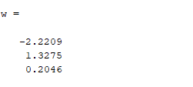

Figure 7 equation of the line that separates the two batches

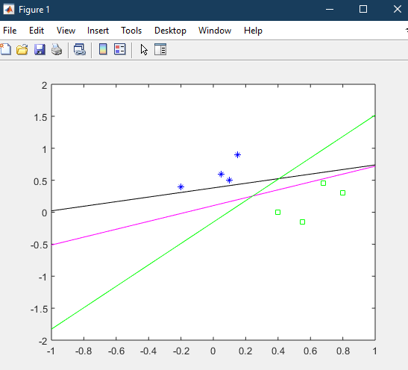

Figure 8 plot of all three different lines to separate batches

All the lines did separate the classes like they were programmed to do; however, the one best solution is the sum of errors line. This line is the best one because it created a line that shot straight down the middle of both batches giving our future features a greater chance to be correct.